Name: _____________________ Class:__________ Date:__________
Instructions: Write answers in the right-hand column. Score: ___________ / 46 marks
Section A—Multiple choice (10 marks)

 | Which of the following is a chemical change?  A Sawdust is produced from wood being cut by a power saw.  B Water freezes to form ice.  C Fireworks explode in a colourful light display.  D Juice is obtained from an orange. | C | 1
 | Describe the particles in a solid.  A The particles in a solid are strongly bonded to each other so the solid has a definite shape.  B The particles in a solid are strongly bonded to each other so the solid does not have a definite shape.  C The particles in a solid are weakly bonded to each other so the solid has a definite shape.  D The particles in a solid are weakly bonded to each other so the solid does not have a definite shape. | A | 1
 | Indentify why gases are easily compressed.  A the particles can diffuse  B there is pressure between particles squashing them together  C there is great energy between the particles allowing them to change  D there is a lot of space between the particles | D | 1
 | Define melting point.  A Melting point is the temperature at which a liquid changes to a gas.  B Melting point is the temperature at which a solid changes to a gas.  C Melting point is the temperature at which a liquid changes to a solid.  D Melting point is the temperature at which a solid changes to a liquid. | D | 1
 | Recall the scientific term used to describe the process of a gas changing to a liquid.  A evaporation  B boiling  C condensation  D sublimation | C | 1
 | A permanent colour change may be an indication that a chemical reaction has taken place. Identify which of the following is not an indication of a chemical reaction.  A sugar caramelising  B toast bread  C a glass breaking  D burning a match | C | 1
 | Analyse the word equation:  methane + oxygen → carbon dioxide + water + energy  This reaction shows that:  A oxygen is a product of this reaction.  B methane burns with a sooty flame.  C this is an exothermic reaction.  D a constant input of energy is required to keep the reaction going. | C | 1
 | As a solid object is heated, its particles:  A vibrate less rapidly and cause it to contract.  B vibrate more rapidly and cause it to expand.  C attract each other more, causing contraction.  D shrink in size so the gaps between them increase. | B | 1
 | A stone has a volume of 6 cubic centimetres and a mass of 12 grams. Its density is:  A 2.00 g/cm³  B 0.50 g/cm³  C 17 g/cm³  D 66 g/cm³ | A | 1
 | Identify which of the following would indicate an endothermic reaction.  A a gas is given off  B the reaction glows  C a precipitate forms  D the reaction feels cold to the touch | D | 1
Section B—Short answer (26 marks)

- ` | Draw diagrams to show the particles in each of the three states of matter. | 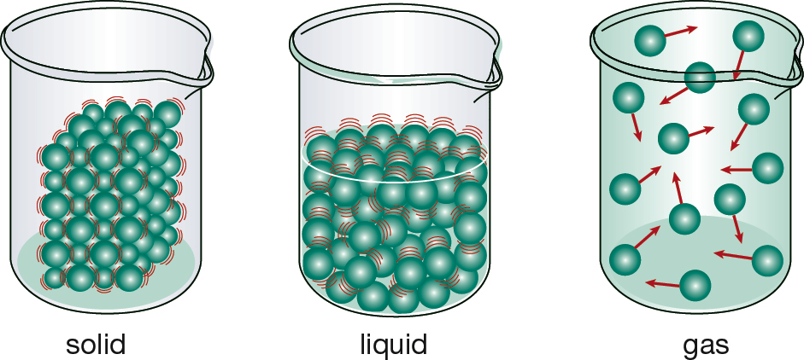 | 3
 | Identify three signs that a chemical reaction has occurred. | Any three of:  • there is a permanent colour change  • a gas is given off  • energy is released or absorbed  • a precipitate forms in solution | 3
 | Explain why endothermic reactions cannot be spontaneous reactions. | Endothermic reactions absorb energy so need a constant input of energy from their environment to keep the reaction going. Because they do not produce energy, the reaction cannot sustain itself. | 2
 | Explain the difference between evaporation and boiling. | Evaporation is when a liquid is changing state into a gas at the surface of the liquid. It can occur at any temperature that the substance is a liquid. Boiling is when bubbles of gas form inside the liquid and only occurs once the liquid reaches a certain temperature i.e. the boiling point. | 1
 | Identify the ‘states of matter’ and their changes on the diagram.  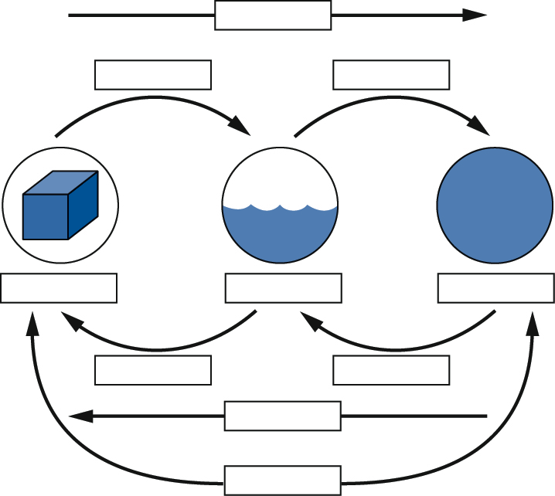 | 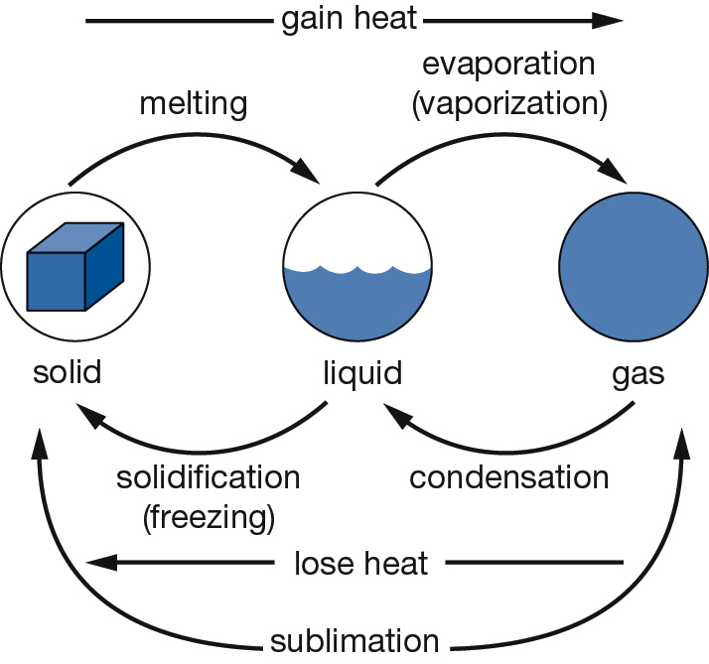 | 5
 | A 1 m rod of steel expands 0.011 mm for each 1°C that its temperature increases. Calculate how much the following rods expand.  a A 1 m steel rod which increased its temperature by 10°C.  b A 1 m steel rod which increased its temperature by 3°C.  c A 2 m steel rod which increased its temperature by 1°C.  d A 5 m steel rod which increased its temperature by 2°C. | a 0.11 mm  b 0.033 mm  c 0.022 mm  d 0.11 mm | 4
 | Calculate the density of a piece of glass with a mass of 24 g if its volume is  8 cm³. | 3 g/cm | 2
 | Calculate the density of a cube of wood measuring 2 cm along each side, and having a mass of 11.2 g. | V = 2 x 2 x 2 = 8 cm³  Density = m/V = 11.2/8 = 1.4 g/cm | 2
 | Solid A has a density of 1.2 g/cm, solid B has a density of 0.8 g/cm and solid C has a density of 1.5 g/cm.  All three are placed in liquid D which has a density of 1.2 g/cm.  Predict the positions of the solids if they are placed in a beaker of the liquid. Draw a beaker showing you prediction. | 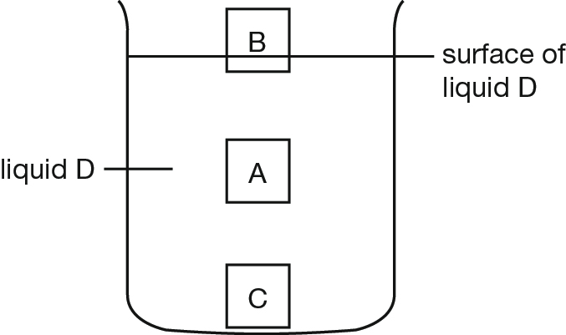 | 2
 | Recall three different types of models. | Computer model, scientific model, weather model, scale model, plans (e.g. for a house) | 2

Section C—Thinking scientifically (10 marks)

 | Joe collected some snow and placed it in a beaker. During the day it melted to produce clear water. Joe and his friends made the following comments about the process.  Joe: This is a chemical change as there is a change in colour.  Jill: The beaker is now warmer than when you collected the snow. This must be a chemical change as energy is absorbed.  Jenny: This is a physical change as the trapped air bubbles react with the snow.  Jamal: This is a physical change as no new substances are created.  State who you believe is correct.  A Joe  B Jill  C Jenny  D Jamal | D | 1
 | An object will float in a liquid if the object is less dense than the liquid. It will sink if the object is denser than the liquid. Four identical balls are dropped in four different liquids shown below. Which liquid is most dense?  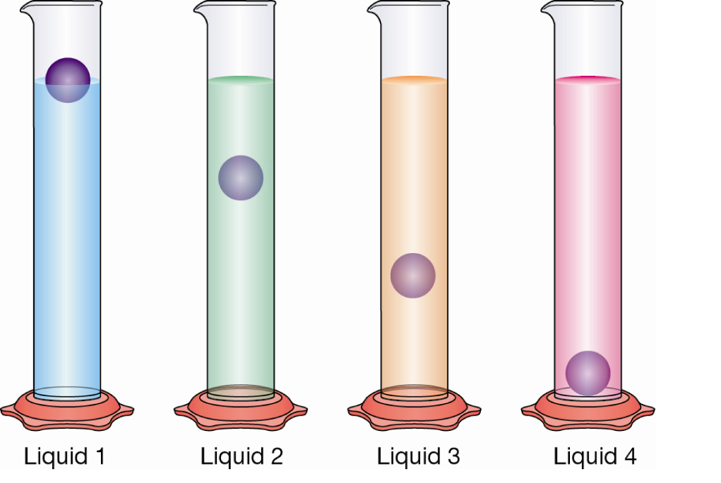  A liquid 1  B liquid 2  C liquid 3  D liquid 4 | A | 1
 | Matter can be solid, liquid or gas. These are known as the states of matter. Substances are converted between different states of matter via the processes shown in the diagram below.  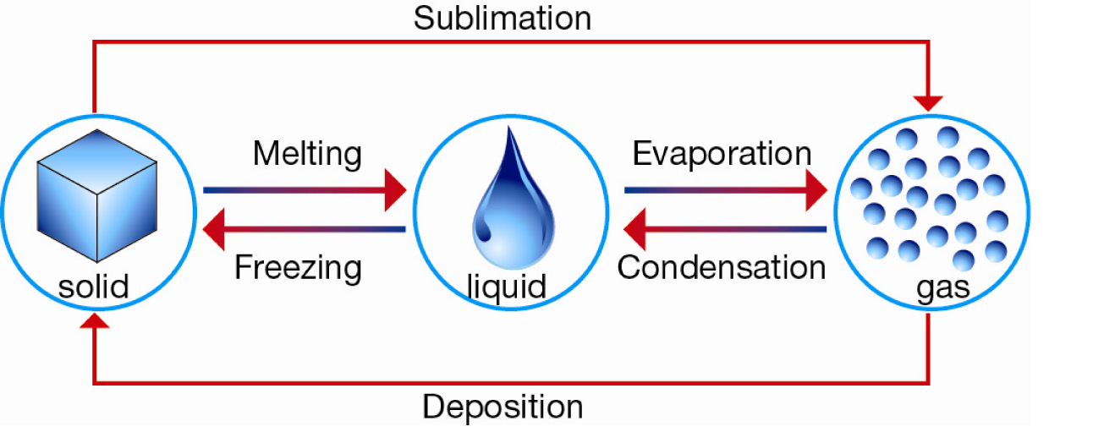  Below -78.5°C carbon dioxide is a solid. Above this temperature it is a gas. Determine which process carbon dioxide would undergo as the temperature is raised from -80°C to -75°C.  A evaporation  B sublimation  C melting  D condensation | B | 1
 | A student carries out an experiment to determine the effect of different types of salt solutions on an iron nail. Identify the purpose of the test tube containing the nail and water only.  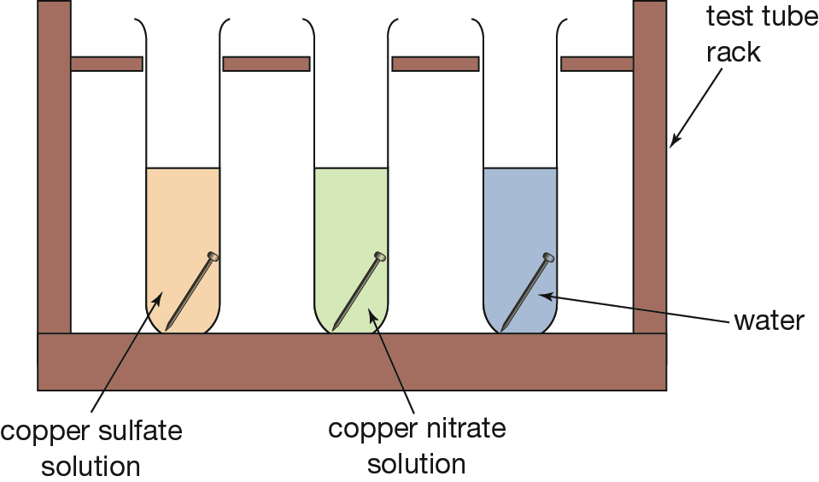  A The water is added to test the strength of the nail.  B All of the answers are correct.  C The test tube acts as a control for the experiment.  D This test tube allows a comparison between copper nitrate and copper sulfate. | C | 1
 | Density is a measure of the total amount of mass in a certain volume. Below are four 1 cm cubes of different metals.  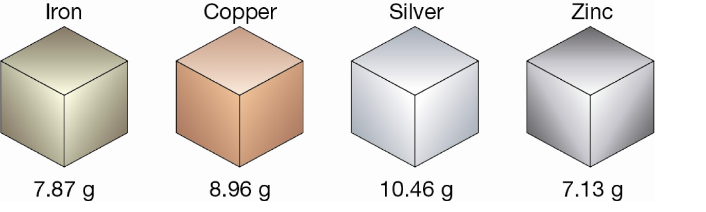  The metal with the lowest density is:  A iron  B copper  C silver  D zinc | D | 1
 | When metals are heated they expand because the particles that make up the metal crystal lattice vibrate more. This means that metal wires will increase in length as they are heated.  However, different metals expand at different rates. The graph below shows how much one meter of aluminium wire increases in length with an increase in temperature. In this graph, the increase in length is measured in millimetres.  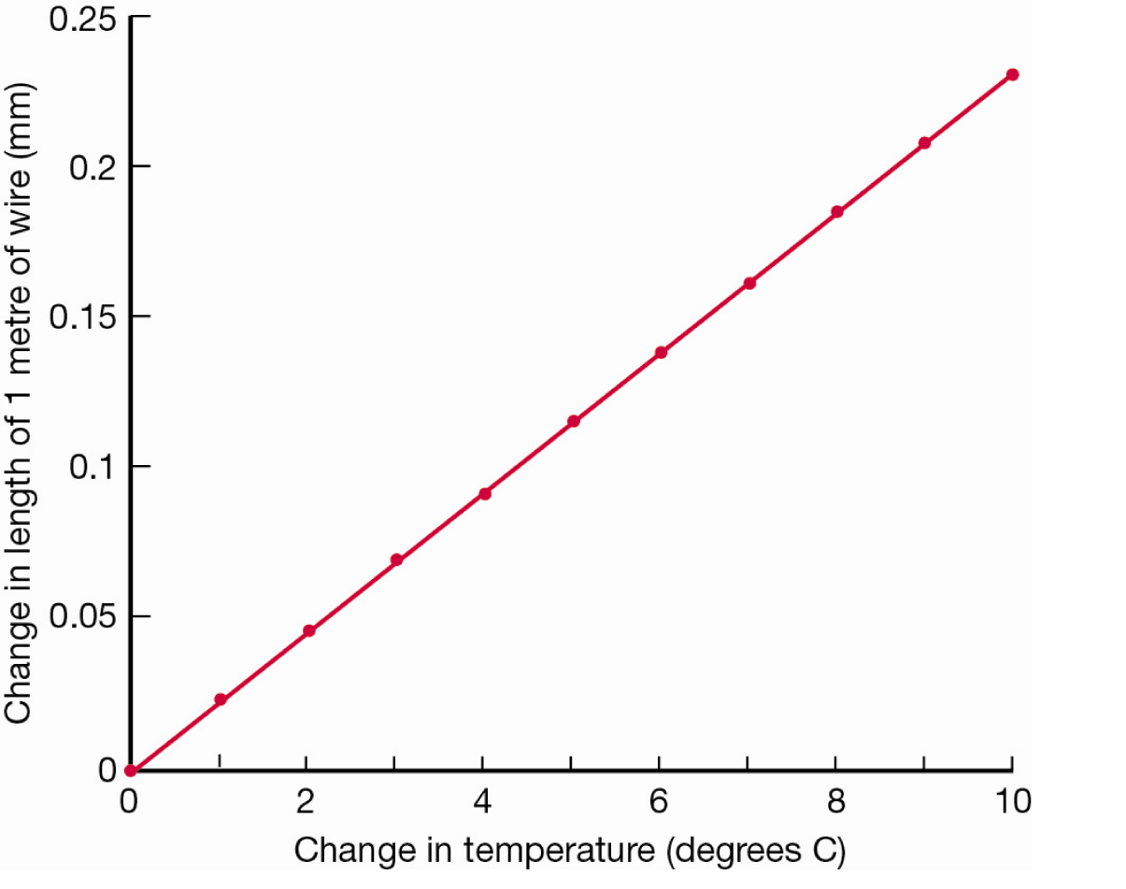  From this graph, determine how much a 10 m long aluminium wire would increase in length if the temperature was increased by 10°C  A 0.025 mm  B 0.23 mm  C 2.3 mm  D 23 mm | C | 1
 | When a gas is stored inside a closed container, the gas exerts a pressure on the sides of the container. The amount of pressure is determined by:  1 how frequently the gas particles hit the sides of the container  2 how fast the particles are moving when they hit the side of the container.  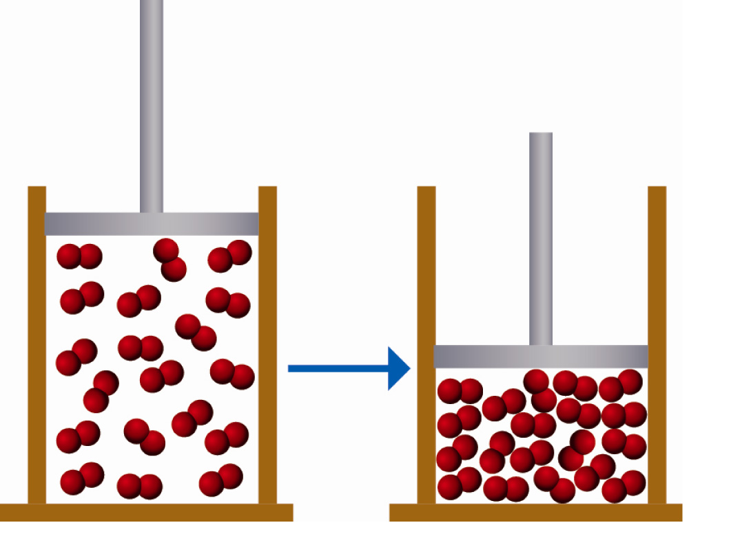  If the volume of the container is halved, you would expect:  A the pressure to increase, because the particles have less room so will hit the side of the container more frequently.  B the pressure to increase, because the particles will travel faster.  C the pressure to decrease, because the particles have less room will hit the side of the container less frequently.  D the pressure to decrease, because the particles will travel slower. | A | 1
 | The density of a substance can be calculated using the formula:  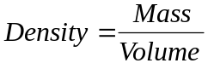  The objects below are made up of 1 cm³ blocks of iron, each weighing 7.87 g.  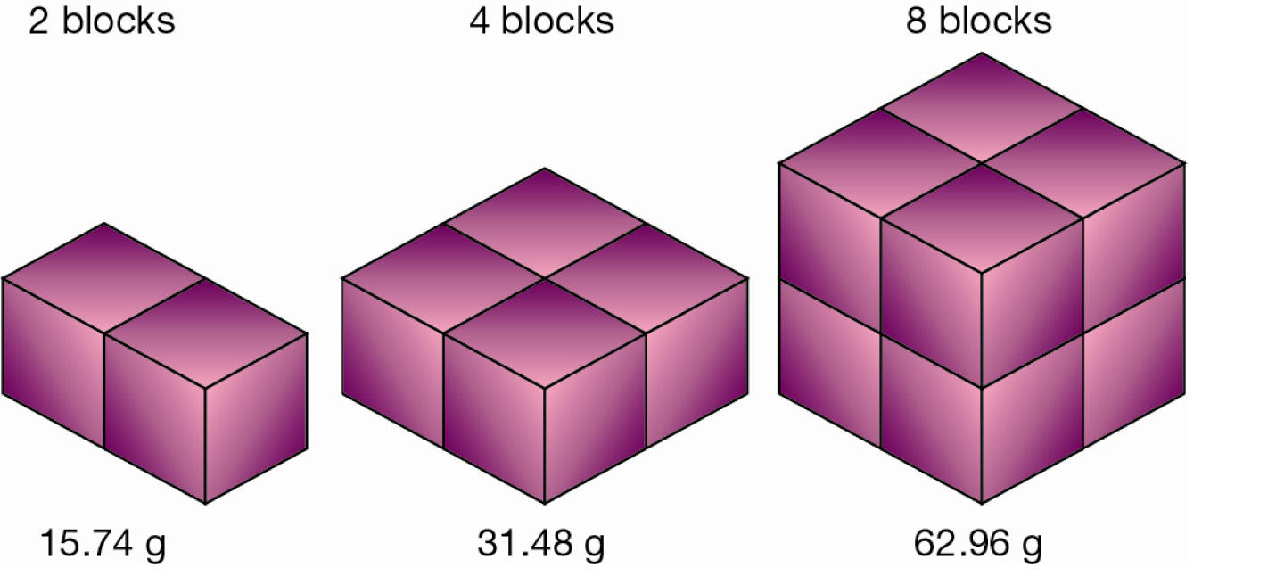  Which of these objects has the highest density?  A 2 blocks  B 4 blocks  C 8 blocks  D They all have the same density. | D | 1
 | The recycling of aluminium can be considered a series of physical changes as shown by the flow diagram below.  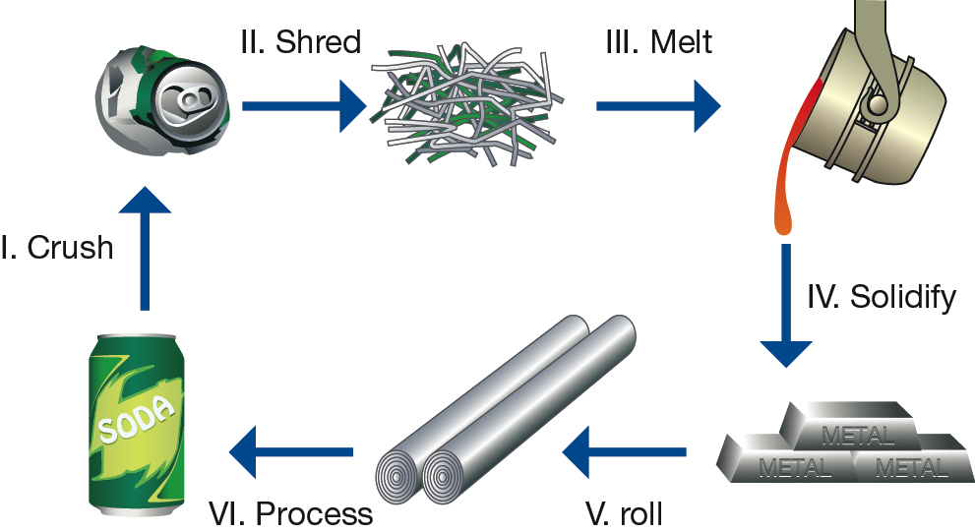  Which stages of the aluminium recycling process would be considered a change of state?  A I and II  B II and III  C III and IV  D only III | C | 1
 | The Law of Conservation of Mass states that ‘During a chemical reaction, atoms are neither created nor destroyed’. This law suggests that if a chemical reaction occurred inside a closed container, the total mass of the container and its contents would:  A increase as more chemicals are produced by the reaction.  B decrease if the chemical reaction produces a gas.  C stay the same.  D increase or decrease depending on the type of chemical reaction. | C | 1

